**WEEK 1 TASK**

**NAME: PRAVARA SINGRU**

**Exhaustive Analysis of Indian Agriculture**

**STEP 1:** Open Power BI software



**STEP 2:** Click on blank report

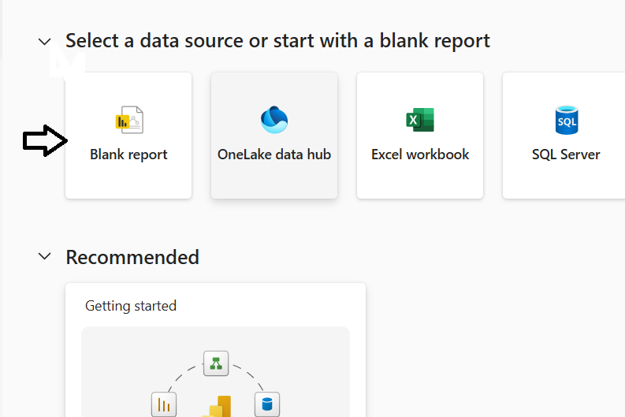

**STEP 3:** Go to get data and select txt/csv

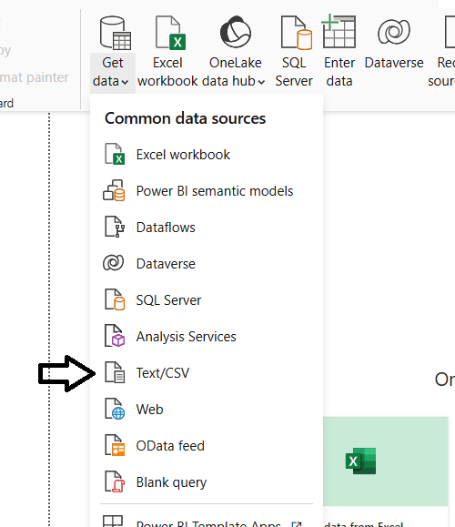

**STEP 4:** Load the data

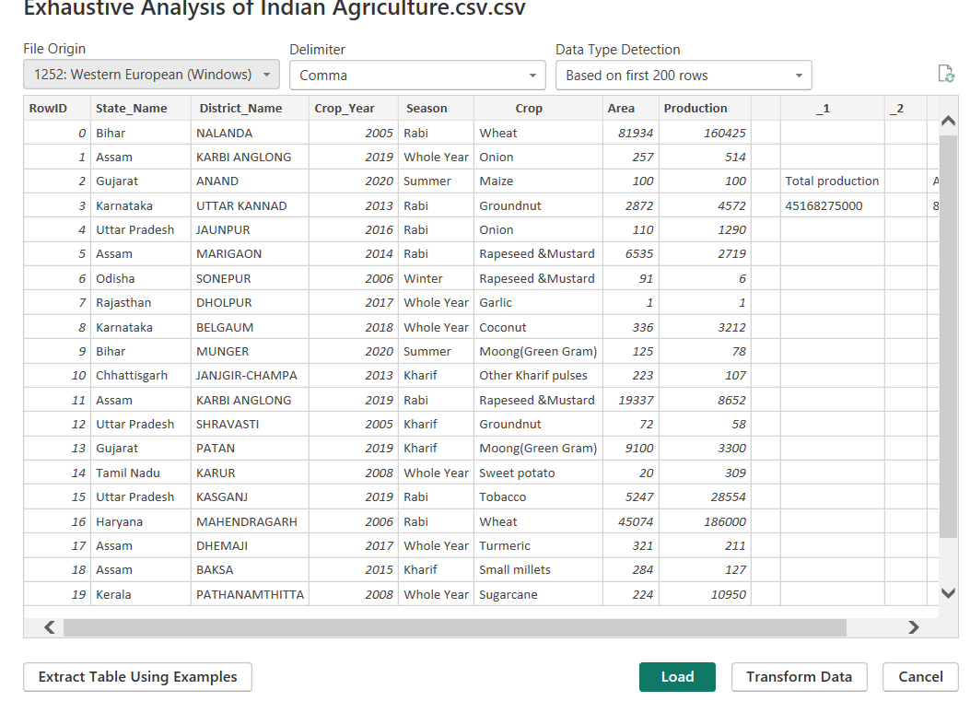

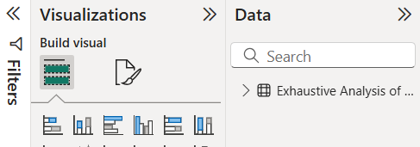

After clicking on the load option we can see our csv file in data block as shown in the above image.

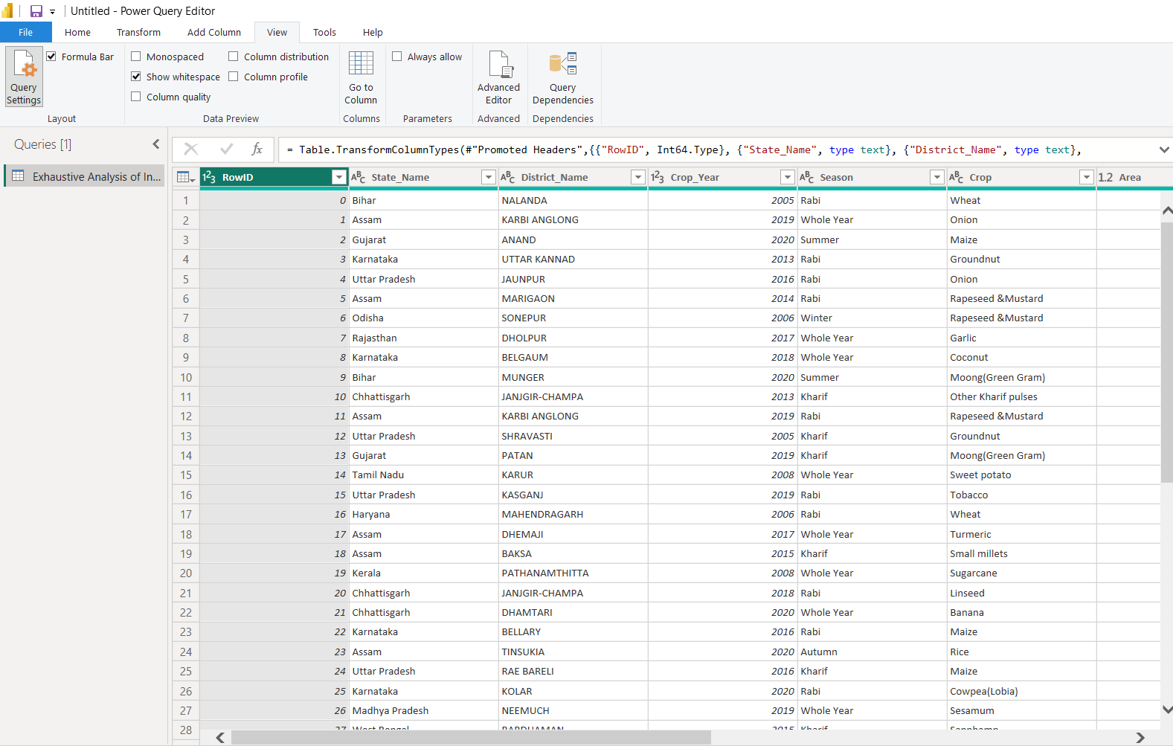 **STEP 5:** Click on the transform data option we directly goes into new tab i.e. Power Query Editor

**STEP 6:** We can delete unwanted rows and columns by right clicking on those rows and columns.

After deleting go to home tab and click on close and apply option we get our modified csv file in Power BI.

